Business Requirements Document (BRD) v1.0

Project Management

Project Number #
Project Name
CR #
Business Owner
Functional Area
Description

Change Management

Business Review
Business Area | Name | Revision # | Comments | Date | Initials

IT Review
Role | Name | Revision # | Comments | Date | Initials
Technical Team Lead
Solutions Team Lead
ARB Team Lead
Project Mgmt Team Lead

Revision History
Date | Revision # | Author | Comments

Table of Contents
1. Introduction 3
2. Use Case (Describes the job performed by the customer) 4
2.1.1. Storyboard 4
2.1.2. Primary Scenario 4
2.1.3. Alternate Scenarios 4
2.1.4. Exception Scenarios 4
3. As Is Analysis (How the customer performs his/her job). 4
3.1.1. Document Current Process Models 4
3.1.1.1. Process Models (SIPOC) 4
3.1.1.2. Business Rules 4
3.1.1.3. Constraints 4
3.1.1.4. Data Elements 5
3.1.2. Document Current Set of Features (delivered by Product/Systems) 5
3.1.2.1. Functional Features 5
4. To Be Analysis (Capture Desired Outcomes) 5
4.1.1. Desired Outcomes 5
5. Opportunity Assessment (Identify which outcomes to pursue) 6
5.1.1. Identify the Opportunities 6
5.1.2. Prioritize the Opportunities 7
6. Gap Analysis (Identifies the changes to processes & features) 7
6.1.1. Document Future Process Models 7
6.1.1.1. Process Models (SIPOC) 7
6.1.1.2. Business Rules 7
6.1.1.3. Constraints 7
6.1.1.4. Data Elements 8
6.1.2. Document Future Set of Features (delivered by Product/Systems) 8
6.1.2.1. Functional Features 8
6.1.3. Glossary 8

Introduction

The business requirement document should fully describe the key processes, data, rules constraints and features that address the desired outcomes identified by the customer. One or more BRDs are associated with a business scenario (job performed by a customer). It covers business, functional and non-functional requirements also implementation and other constraints necessary to provide a complete and comprehensive description of the requirements for the project. We’ll use a simple 5-step process to capture all the relevant information using a consistent set of structures, metadata and indices to manage the data and enable traceability throughout the execution phases (SDLC):

Step 1: Document the scenarios and actors for a given job the customer is performing
Step 2: Capture the “As Is Analysis” of current processes used to perform the job
Step 3: Capture the “To Be Analysis” of how the customer “ideally” wants to perform the job (desired outcomes)
Step 4: Conduct an “Opportunity Assessment” to identify & prioritize opportunities to pursue in the project
Step 5: Conduct the “Gap Analysis” to document the business requirements to be implemented in the project
Step 6: Document the “User Acceptance” Test Cases

Development Methodology

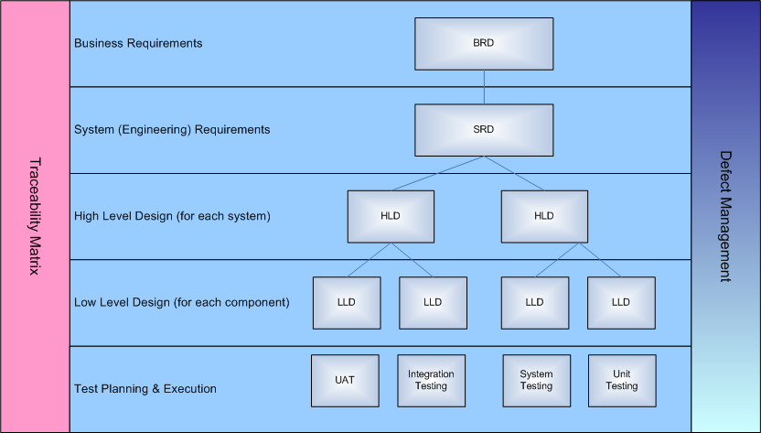

Use Case (Describes the job performed by the customer)

Storyboard
Describe how the job is performed today by the customer. Identify who is involved in completing the job and identify the outcomes that they are trying to achieve.

Primary Scenario

Alternate Scenarios

Exception Scenarios

As Is Analysis (How the customer performs his/her job).

Document Current Process Models

Process Models (SIPOC)
If they are documented, insert them here (or reference them in ARIS)
IF not, create a SIPOC (see example below)
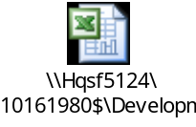

Business Rules
This section describes what the system needs to do. Rules can be applied at various levels of granularity with in the process models
Business Rules # | Process ID | Business Rules Detail
[BR0001] | 13.2.1 | If order > $50,000, Then obtain approval from Sales Manager

Constraints
This section describes what the system cannot do. Constraints can be applied at various levels of granularity with in the process models.
Constraint # | Process ID | Constraint Detail
[CON0001] | 1.0 | All information must be recorded for FDA auditing

Data Elements
This section should capture all key data elements identified by the business to support processes and/or reporting needs.
Data Element | Process ID | Description
[BR0001] | 13.2.1 | If order > $50,000, Then obtain approval from Sales Manager

Document Current Set of Features (delivered by Product/Systems)

Functional Features
Functional requirements express how the system behaves in response to user/actor “triggered” events (e.g., “When the user/actor does x, the system will do y.”). They map specifically to an established business need (Business Requirement).

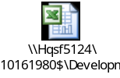

To Be Analysis (Capture Desired Outcomes)
This section reminds the reader the functionality, components or business process not included in this project.

Desired Outcomes
]
Functions | Jobs | Desired Outcomes by Customers | Metrics for Success
Product Engineering | Product Design | Minimize the amount of time it takes to design new products | 6 months for Generic Drugs, 12 months for Biosimilar Drugs, 10 months for Device
Product Engineering | Product Design | Minimize the amount of time it takes to upgrade existing Device products | 3 months for major updates, 1 month for minior updates
Product Engineering | Product Design | Increase the alignment between product features and desired customer outcomes for products | All product features should be derived from customer outcomes  Ensure features are prioritized using an opportunity analysis performed against the customer outcomes
Product Engineering | Product Design | Minimize the compliance overhead associated with product development | Reduce the need for physical paper by 90%  Reduce manual workflows & handoffs by 95%  Reduce time & effort associated with content search by 80%  Reduce manual forms generation for regulatory bodies by 95%  Reduce time & effort associated with compliance mgmt by 80%
Product Engineering | Product Design | Minimize the effort associated with API analysis | Reduce the cycle time with sourcing material suppliers by 50%
Product Engineering | Product Design | Increase the quality of requirements management for product development | Increase the traceability of requirements at the feature and sub-feature level  Reduce the need for re-creating requirements by adopting a component-based approach for documenting requirements
Product Engineering | Product Definition & Configuration Management | Minimize the effort required to integrate information between functional areas
Product Engineering | Product Definition & Configuration Management | Minimize the effort required to manage functional and performance modeling for products throughout the development lifecycle
Product Engineering | Product Definition & Configuration Management | Increase the ability to perform prototyping and simulation to validate product designs
Product Engineering | Product Definition & Configuration Management | Increase the visualization of product features for product development and early stage (alpha) customers to assess whether desired outcomes are being met

Opportunity Assessment (Identify which outcomes to pursue)

Identify the Opportunities

Desired Outcomes by Customers | Importance  (1-10) | Satisfaction  (1-10) | Opportunity  Imp + (Imp-Satisf)
Minimize the amount of time it takes to design new products
Minimize the amount of time it takes to upgrade existing Device products
Increase the alignment between product features and desired customer outcomes for products
Minimize the compliance overhead associated with product development
Minimize the effort associated with API analysis

Increase the quality of requirements management for product development
Minimize the effort required to integrate information between functional areas
Minimize the effort required to manage functional and performance modeling for products throughout the development lifecycle

Prioritize the Opportunities
Opportunities can have a score that ranges from -10 to 20, so this is the ideal time to review

Prioritization | Range of Scores | Interpretation
Low | -10 <=> 0 | These scores are derived from Low values (1-4) assigned to Importance for a desired outcome with Med to High values (4-10) assigned to satisfaction with current processes/systems.
Medium | 1 <=> 5 | These scores are derived from Medium values (5-6) assigned to Importance for a desired outcome with Low values (1-3) assigned to satisfaction with current processes/systems.
High | 6 <=> 13 | These scores are derived from High values (7-10) assigned to Importance for a desired outcome with Medium values (5-6) assigned to satisfaction with current processes/systems.
Critical | 14 <=> 20 | These scores are derived from High values (7-10) assigned to Importance for a desired outcome with Low values (1-4) assigned to satisfaction with current processes/systems.

Based on the business area and available funds, we may want to only focus on those desired outcomes that fall into the High and Critical prioritization. That subset of desired outcomes sets the scope for the Gap Analysis below.

Gap Analysis (Identifies the changes to processes & features)
This section describes how the processes and systems need to be modified to implement the opportunities identified as the highest priority (those that fall into the scope mentioned in 5.1.2).

Document Future Process Models

Process Models (SIPOC)
If they are documented, insert them here (or reference them in ARIS)
IF not, create a SIPOC (see example below)

Business Rules
This section describes what the system needs to do. Rules can be applied at various levels of granularity with in the process models
Business Rules # | Process ID | Business Rules Detail
[BR0001] | 13.2.1 | If order > $50,000, Then obtain approval from Sales Manager

Constraints
This section describes what the system cannot do. Constraints can be applied at various levels of granularity with in the process models.
Constraint # | Process ID | Constraint Detail
[CON0001] | 1.0 | All information must be recorded for FDA auditing

Data Elements
This section should capture all key data elements identified by the business to support processes and/or reporting needs.
Data Element | Process ID | Description
[BR0001] | 13.2.1 | If order > $50,000, Then obtain approval from Sales Manager

Document Future Set of Features (delivered by Product/Systems)

Functional Features
Functional requirements express how the system behaves in response to user/actor “triggered” events (e.g., “When the user/actor does x, the system will do y.”). They map specifically to an established business need (Business Requirement).

Glossary
Term/Acronym/Abbreviation | Definition

Document Test Cases (UAT)

